Ph: 0485 2832040, 2836188, 8138072040
Email: sncemu@gmail.com, Web: www.sncem.edu.in

Muvattupuzha, Ernakulam Dist, Kerala, Pin - 686661

(Affiliated to MG University, Approved by NCTE

00
Sree Narayana College of Education

KEY INDICATOR
2.4 COMPETENCY AND SKILL DEVELOPMENT
METRIC:2.4.4

s in respect of
Students are enabled to evolve the following tools of assessment for learning suited to the kinds of learning engagement provided to learners, and to analyse as well as interpret responses
1. Teacher made written tests essentially based on subject
content
2. Observation modes for individual and group activities
3. Performance tests
4. Oral assessment
5. Rating Scales

1. Preparation of lesson learning process in respect of

1. Preparation of lesson plans
2. Developing assessment tools for both online and offline learning
3. Effective use of social media/learning apps/adaptive devices for learning
4. Identifying and selecting/ developing online learning resources
5. Evolving learning sequences (learning activities) for online as well as face to face situations

2. Developing assessment tools for both online and offline learning
3. Effective use of social media/learning apps/adaptive devices for learning
4. Identifying and selecting/ developing online learning resources
5. Evolving learning sequences (learning activities) for online as well as face to face situations
1. Preparation of lesson plans
2. Developing assessment tools for both online and offline learning
3. Effective use of social media/learning apps/adaptive devices for learning
4. Identifying and selecting/ developing online learning resources
5. Evolving learning sequences (learning activities) for online as well as face to face situations

related event

3.

Any other relevant information
Teacher made written tests essentially based on subject
content
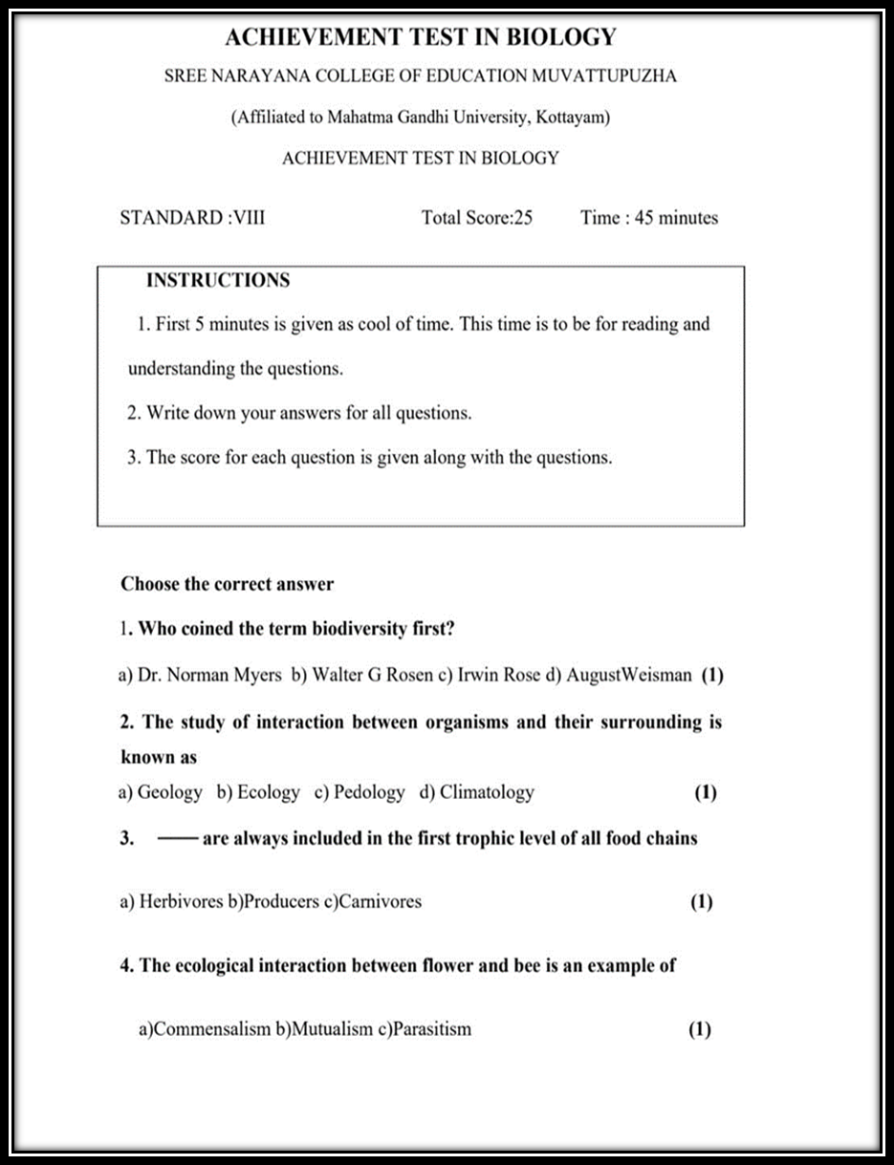

Sample Achievement Test Question paper

Observation modes for individual and group activities

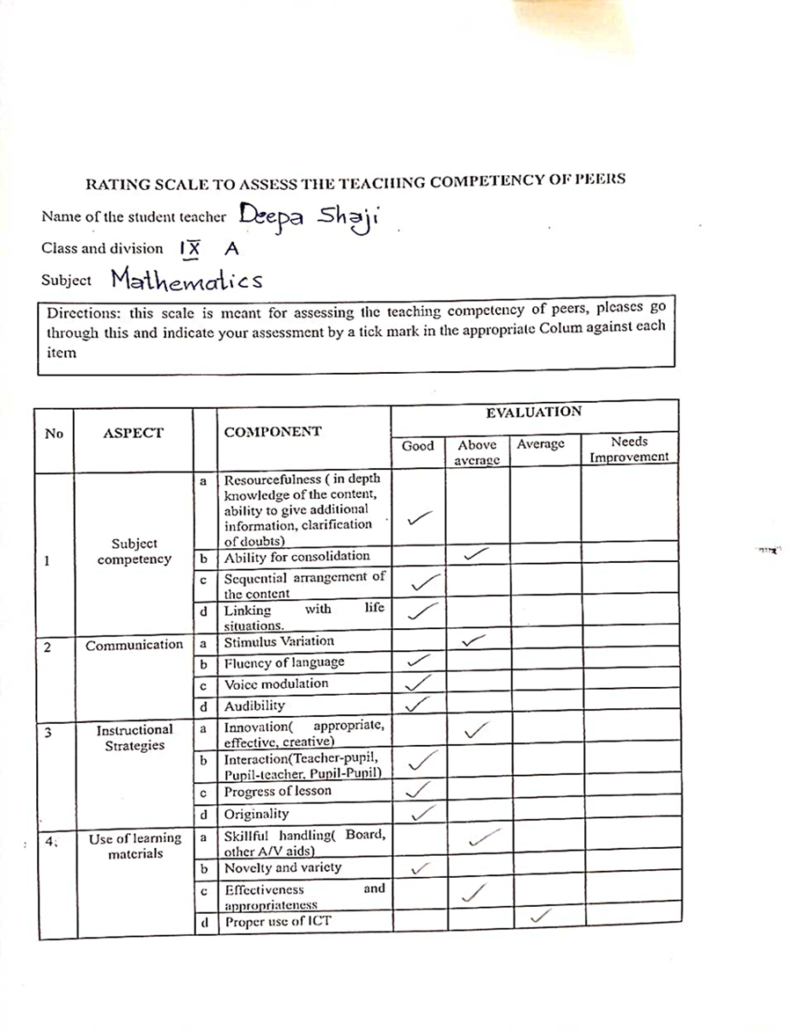
Peer Evaluation

Performance tests

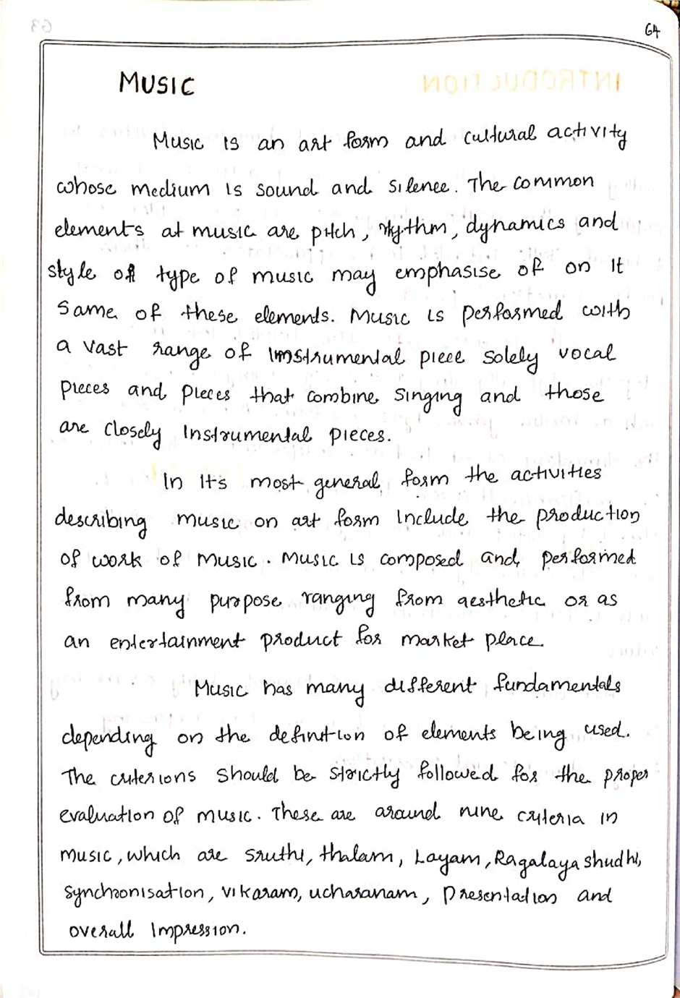

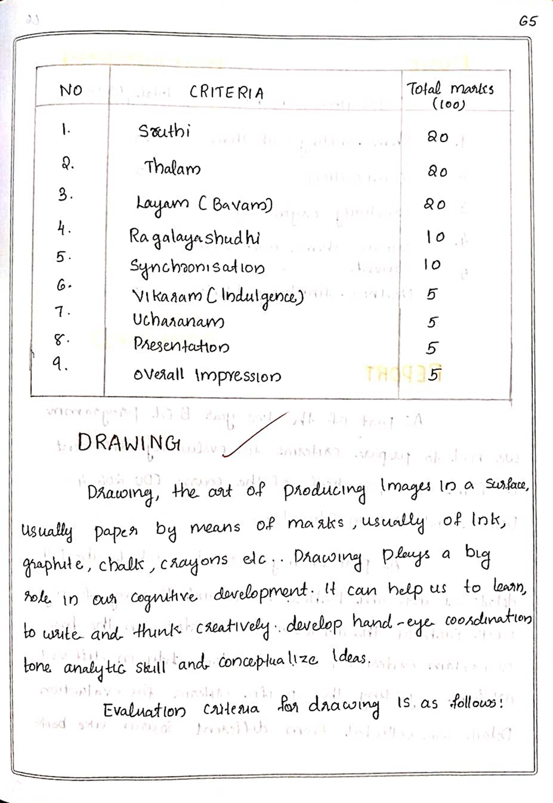

Criteria for evaluating music

Oral Assessment

COMMUNICATIVE ENGLISH ORAL ASSESSMENT PHOTOS

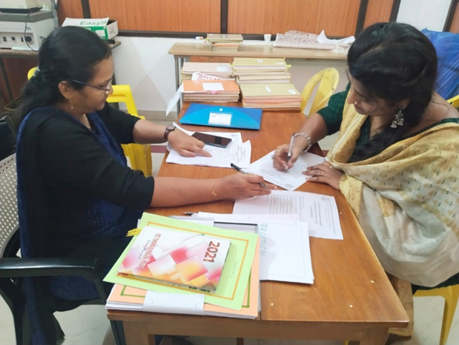
Communicative English Oral Assessment image No.1

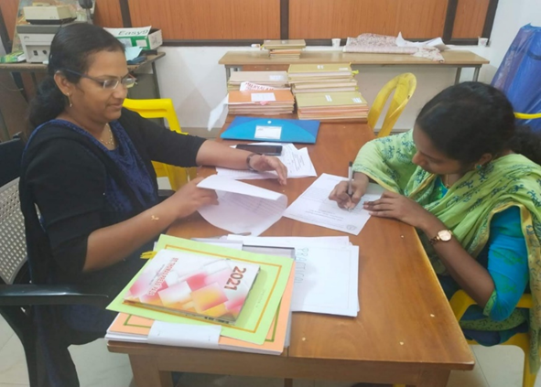
Communicative English Oral Assessment image No.2

Rating scales

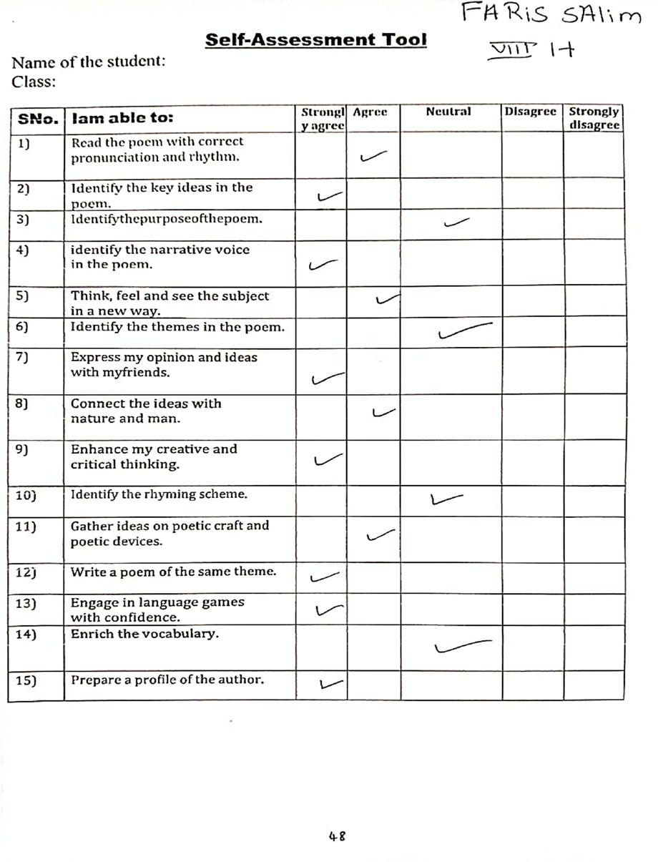
Self Assessment Rating scale

