Ph: 0485 2832040, 2836188, 8138072040
Email: sncemu@gmail.com, Web: www.sncem.edu.in

Muvattupuzha, Ernakulam Dist, Kerala, Pin - 686661

(Affiliated to MG University, Approved by NCTE

00
Sree Narayana College of Education

KEY INDICATOR
2.4 COMPETENCY AND SKILL DEVELOPMENT
METRIC:2.4.5
IAdequate skills are developed in students for effective use of ICT for teaching learning process in respect of

- Preparation of lesson plans
- Developing assessment tools for both online and offline learning
- Effective use of social media/learning apps/adaptive devices for learning
- Identifying and selecting/ developing online learning resources
5. Evolving learning sequences (learning activities) for online as well as face to face situations
s in respect of

1. Preparation of lesson learning process in respect of

1. Preparation of lesson plans
2. Developing assessment tools for both online and offline learning
3. Effective use of social media/learning apps/adaptive devices for learning
4. Identifying and selecting/ developing online learning resources
5. Evolving learning sequences (learning activities) for online as well as face to face situations

2. Developing assessment tools for both online and offline learning
3. Effective use of social media/learning apps/adaptive devices for learning
4. Identifying and selecting/ developing online learning resources
5. Evolving learning sequences (learning activities) for online as well as face to face situations
1. Preparation of lesson plans
2. Developing assessment tools for both online and offline learning
3. Effective use of social media/learning apps/adaptive devices for learning
4. Identifying and selecting/ developing online learning resources
5. Evolving learning sequences (learning activities) for online as well as face to face situations

related event

3.

Additional Information

Preparation of lesson plans

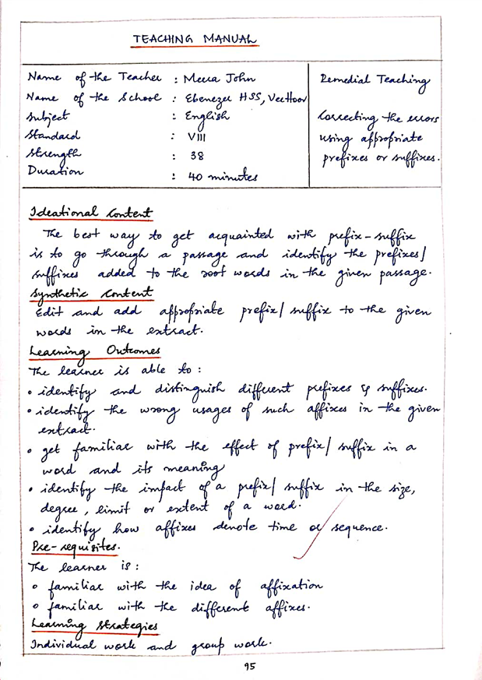

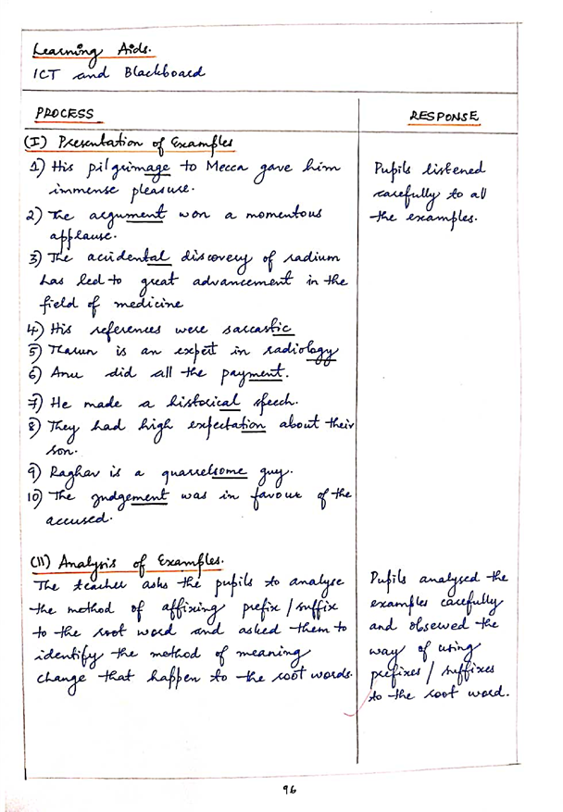

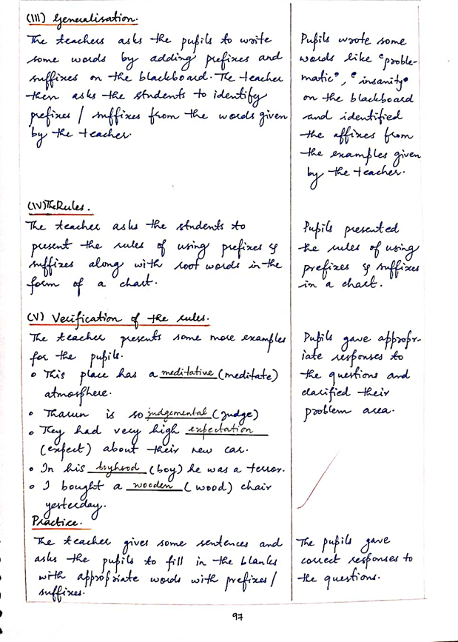

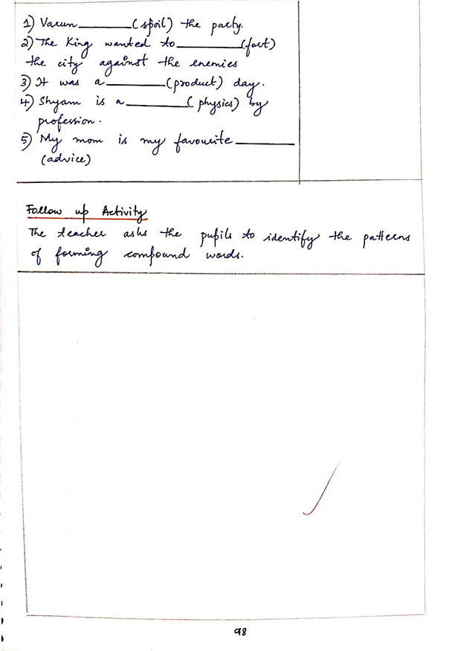

Lesson plan for Remedial Teaching in English

Developing assessment tools for both online and offline learning
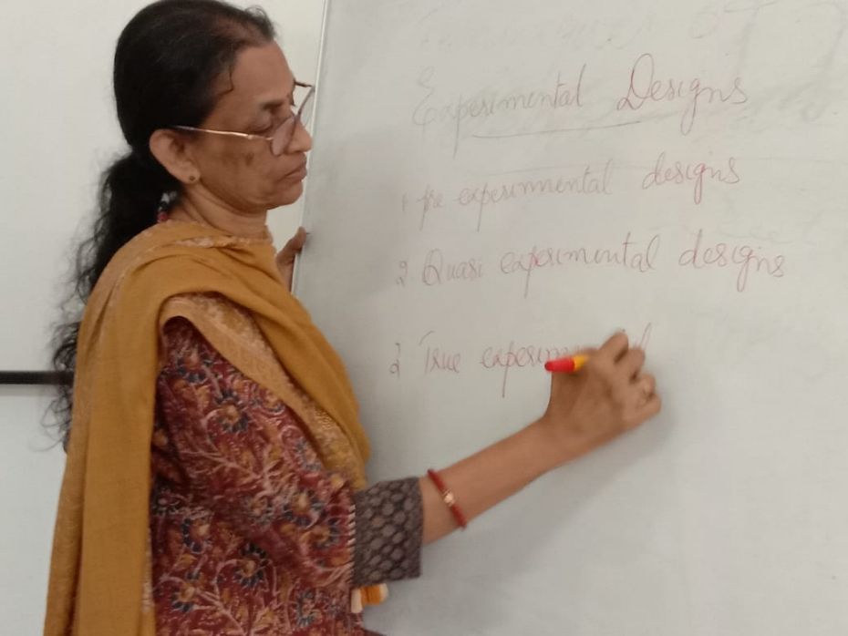
Orientation class on Experimental design

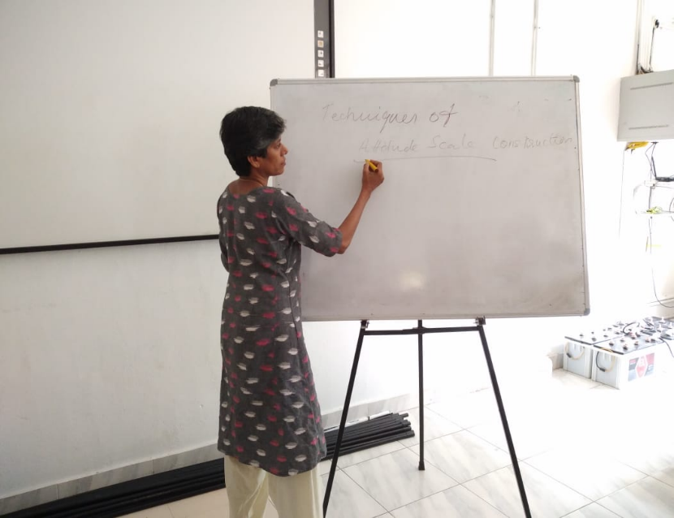
Orientation class on Attitude scale

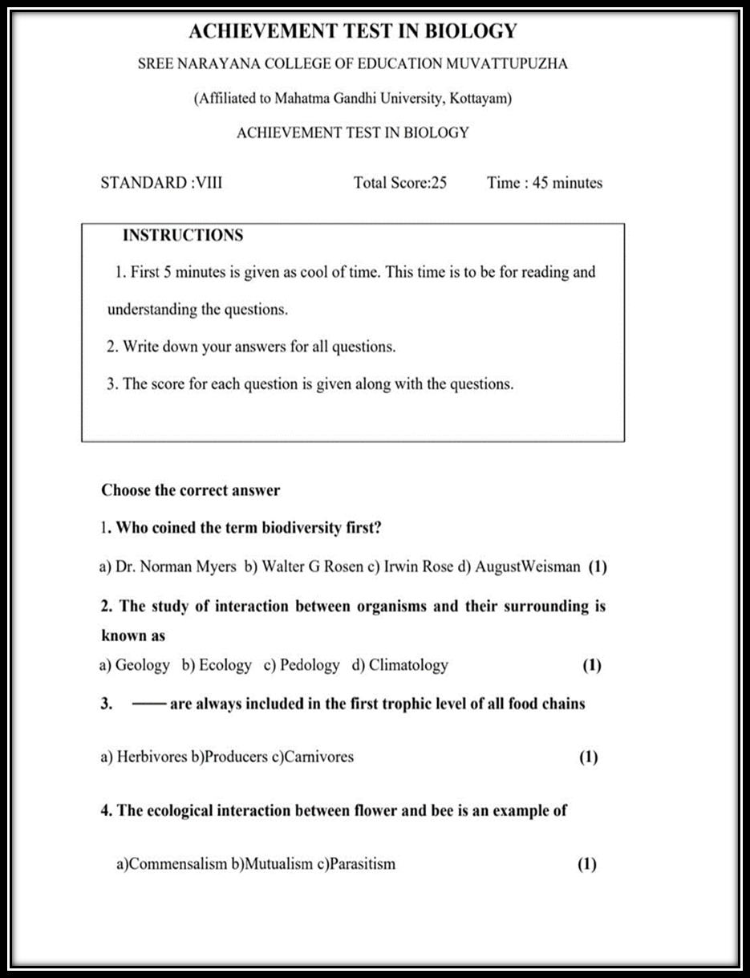
Sample Achievement Test Question paper

Effective use of social media/learning apps/adaptive devices for learning
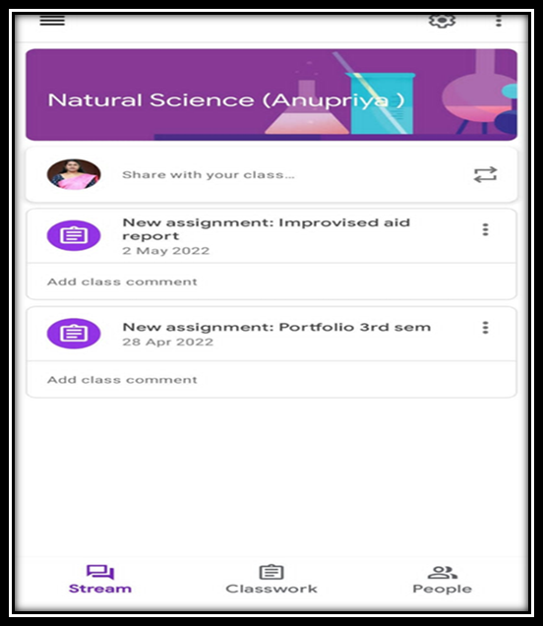
Documents sharing through google classroom

Identifying and selecting/ developing online learning resources

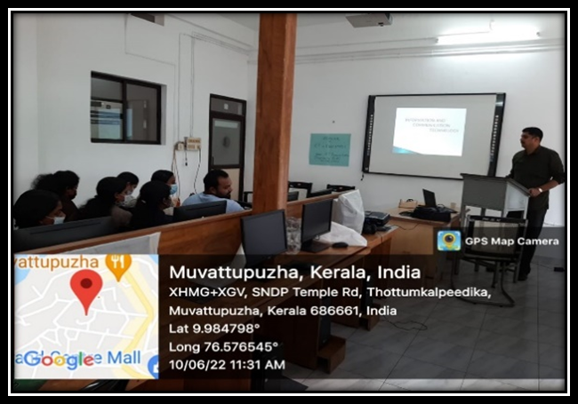
Seminar on ICT

Evolving learning sequences (learning activities) for online as well as face to face situations

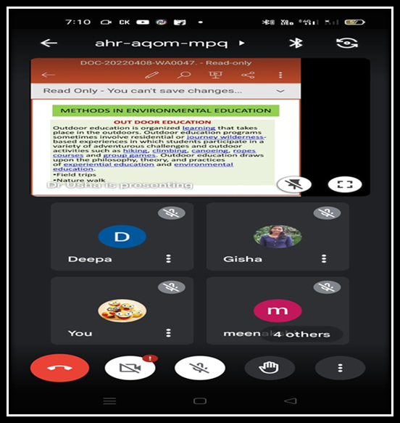
Learning through Google meet

