Ph: 0485 2832040, 2836188, 8138072040
Email: sncemu@gmail.com, Web: www.sncem.edu.in

Muvattupuzha, Ernakulam Dist, Kerala, Pin - 686661

(Affiliated to MG University, Approved by NCTE

00
Sree Narayana College of Education

KEY INDICATOR
2.4 COMPETENCY AND SKILL DEVELOPMENT
METRIC:2.4.6

sStudent’s develop competence to organize academic, cultural, sports and community related events through
1. Planning and scheduling academic, cultural and sports events in school
2. Planning and execution of community related events
3. Building teams and helping them to participate
- Involvement in preparatory arrangements
- Executing/conducting the event
arning process in respect of

1. Preparation of lesson plans
2. Developing assessment tools for both online and offline learning
3. Effective use of social media/learning apps/adaptive devices for learning
4. Identifying and selecting/ developing online learning resources
5. Evolving learning sequences (learning activities) for online as well as face to face situations

2. Developing assessment tools for both online and offline learning
3. Effective use of social media/learning apps/adaptive devices for learning
4. Identifying and selecting/ developing online learning resources
5. Evolving learning sequences (learning activities) for online as well as face to face situations
1. Preparation of lesson plans
2. Developing assessment tools for both online and offline learning
3. Effective use of social media/learning apps/adaptive devices for learning
4. Identifying and selecting/ developing online learning resources
5. Evolving learning sequences (learning activities) for online as well as face to face situations

related event

3.

Any other relevant information

Planning and scheduling academic, cultural and sports events in school

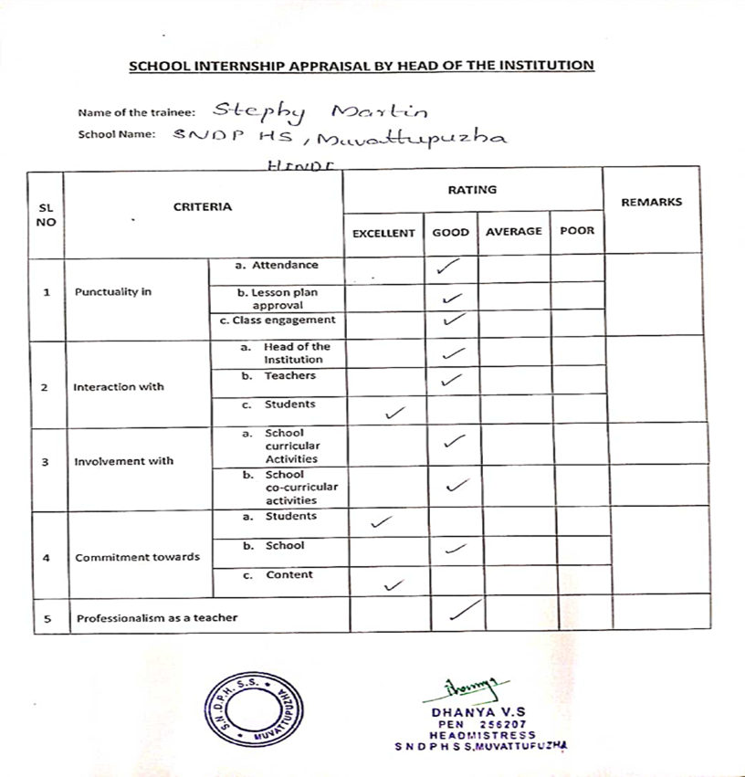
School internship appraisal by head of the institution

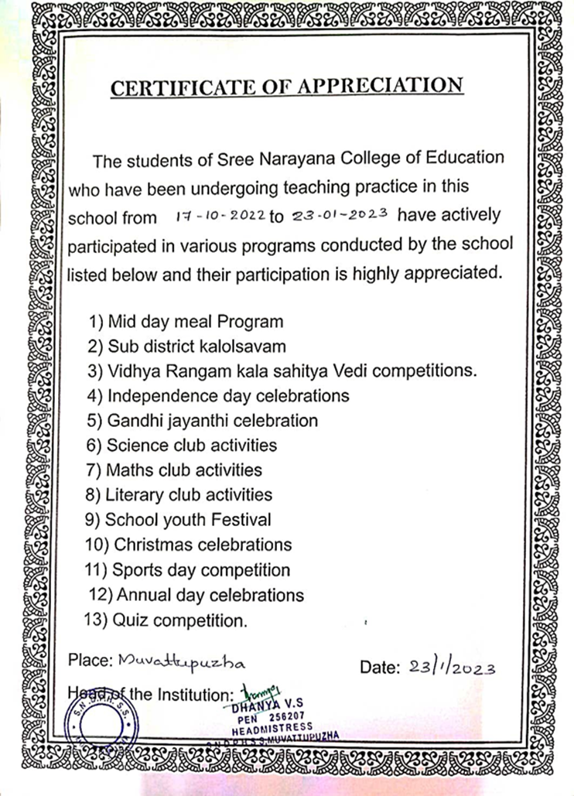
Certificate of appreciation to student teacher provided by Head of the institution

Planning and execution of community related events

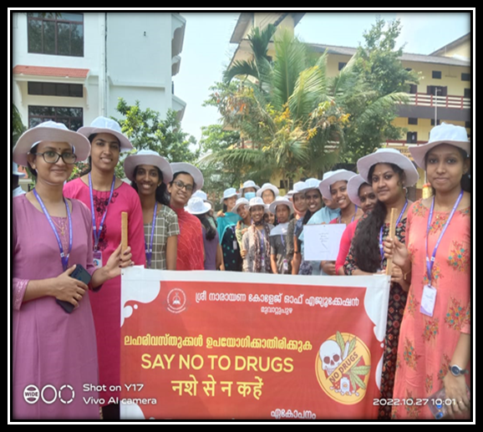
Social awareness rally on drug abuse at 27/10/2022

Building teams and helping them to participate

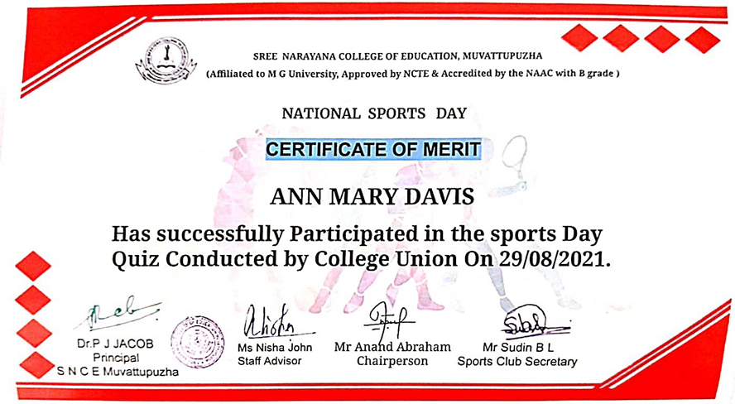
Certificate of merit provided for successful participation in sports day quiz

Involvement in Preparatory Arrangements
Brochures of different events held in college
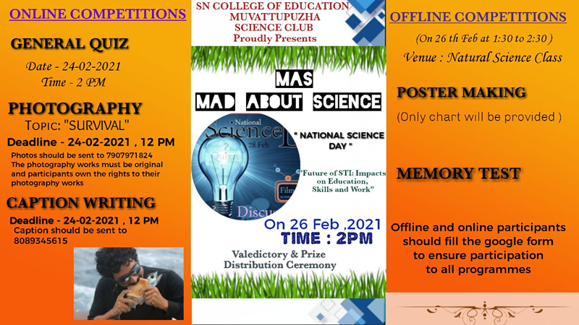
National science day celebration at 26/02/2021
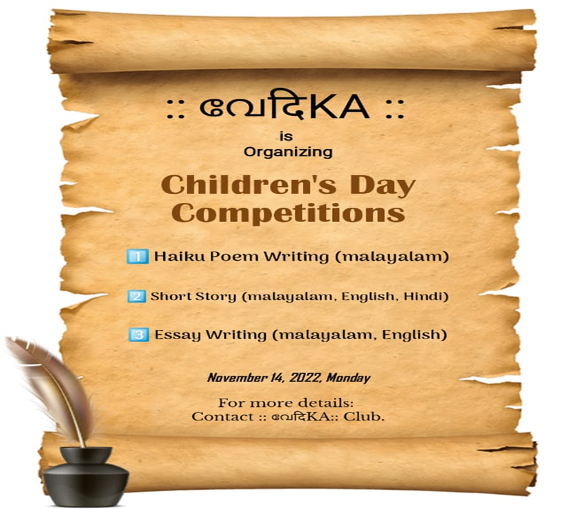
Vedika club organized childrens day competitions on 14/11/2022

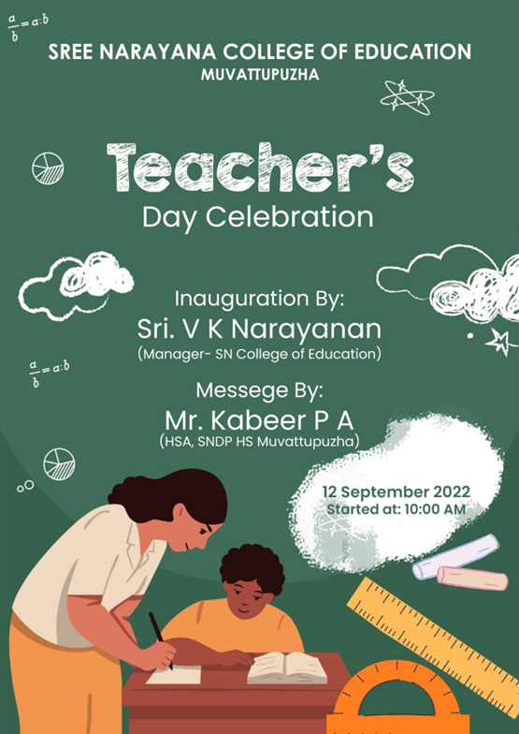
Teacher’s day celebration on 12/09/2022 at college auditorium

Executing/conducting the event

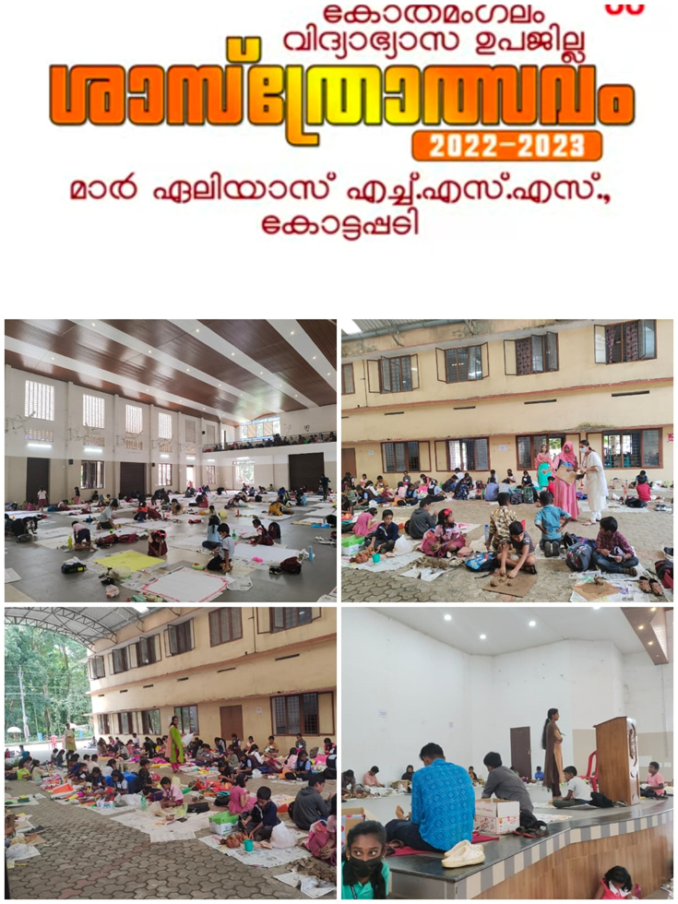
Students on invigilation duty for Kothamangalam sub district science fair held at Mar Elias HSS Kottapady on 20/10/2022

