Ph: 0485 2832040, 2836188, 8138072040
Email: sncemu@gmail.com, Web: www.sncem.edu.in

Muvattupuzha, Ernakulam Dist, Kerala, Pin - 686661

(Affiliated to MG University, Approved by NCTE

00
Sree Narayana College of Education

KEY INDICATOR
2.4 COMPETENCY AND SKILL DEVELOPMENT
METRIC:2.4.3
Competency of effective communication is developed in
Student’s through several activities such as

1. Workshop sessions for effective communication

2. Simulated sessions for practicing communication in
different situations

3. Participating in institutional activities as ' anchor
'discussant' or 'rapporteur'

4. Classroom teaching learning situations along with
teacher and peer feedback
related events through develop competence to organize academic, cultural, sports and community related event

3.

Any other relevant information
Effective Communication Workshops Conducted

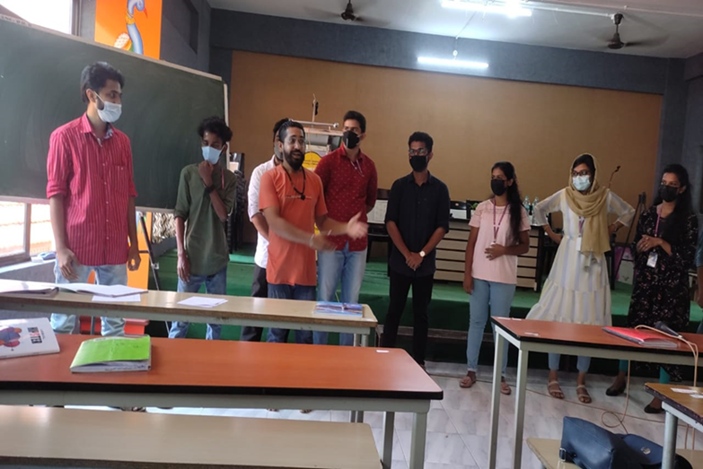
workshop on drama conducted at College Auditorium on 10/08/2022

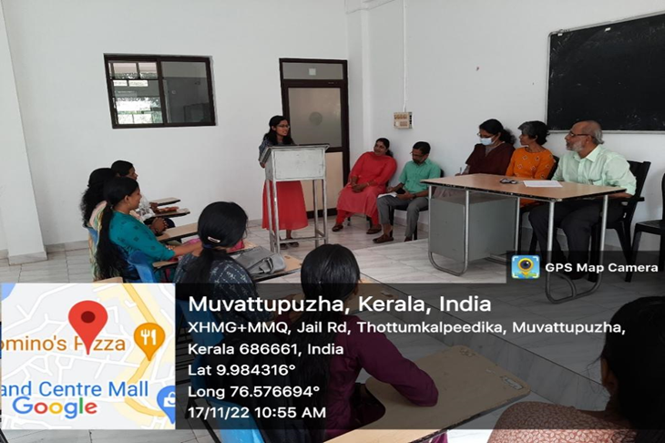
M.Ed Colloquium at M.Ed classroom on 17/11/2022

Simulated sessions for practicing communication in different situations

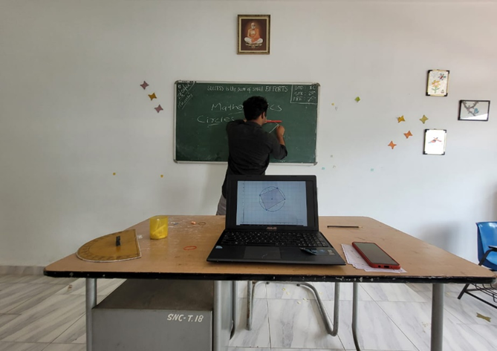
Student seminar at classroom on 10/11/2022

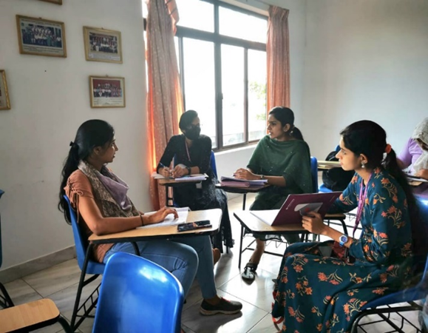
Group discussion among students at classroom on 21/11/2022

Participating in institutional activities as 'anchor', 'discussant' or 'rapporteur

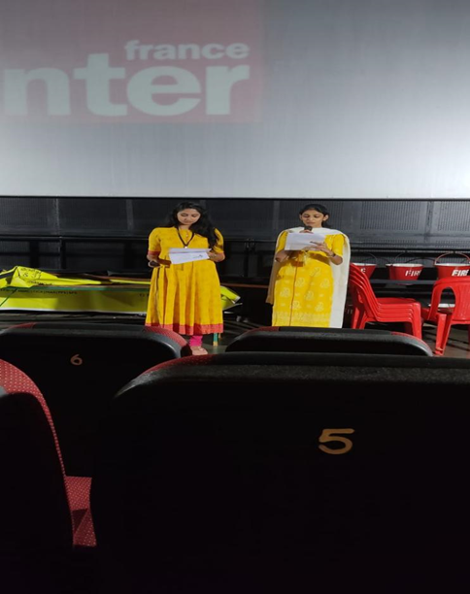
Anchoring of students at film festival conducted by muvattupuzha film society at Latha theatre muvattupuzha on 10/06/2022

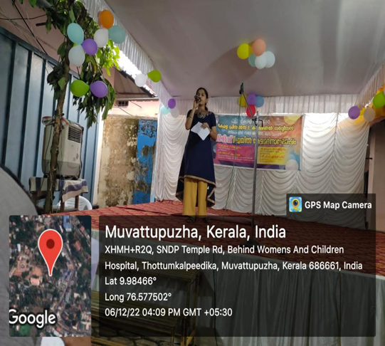
Anchoring of student at Muvattupuzha sub jail on 06/12/2022

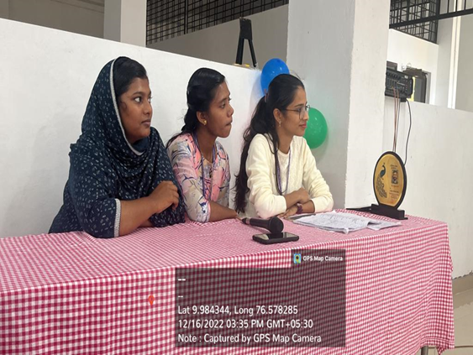

Anchoring of students in club inauguration at college auditorium on 12/16/2022

Classroom teaching learning situations along with teacher and peer feedback

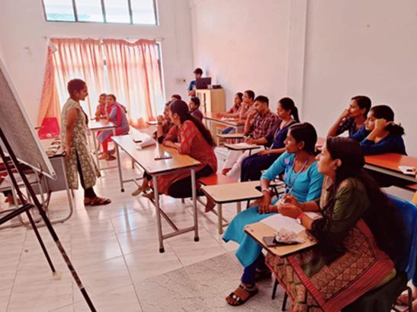
Peer tutoring at classroom on 11/08/2022

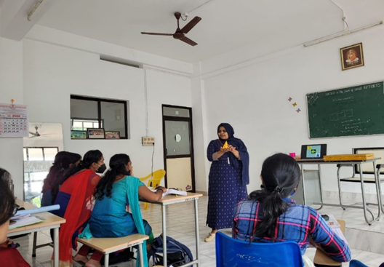
Peer tutoring at classroom on 13/09/2022

